Practical -3 :Importing Data
To extract the data, User needs to click on the Get Data tile and list of common data sources like Excel workbook, Power BI semantic models, Dataflows, Dataverse, SQL Server, Analysis Services, Text/CSV, Web, OData feed, Blank query are available to retrieve the dataset. He may select any of these types to load the data.
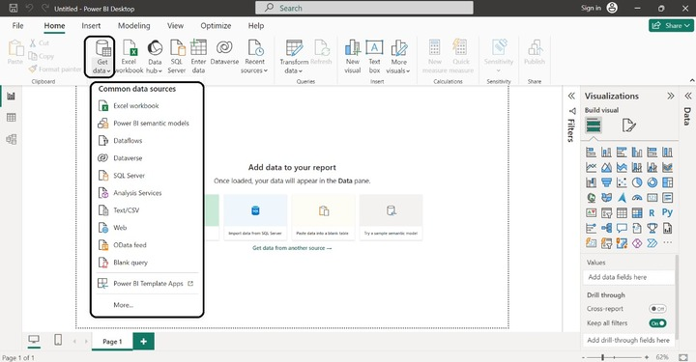
User selects the Excel workbook sources and he has two options either Load or Transform data. Usually, Query Editor would be employed to transform and cleanse the data. We will learn about transforming data in detail in the Power Query Editor chapter. Richard decided to click on the Load and the entire worksheet was imported into the Power BI desktop.
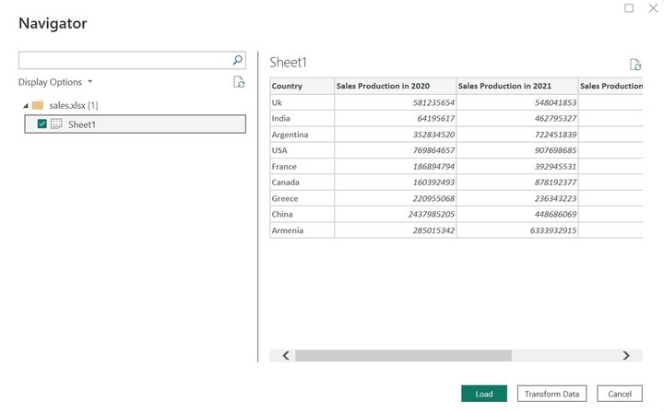
The Data pane indicates the table created in MS Excel data source.
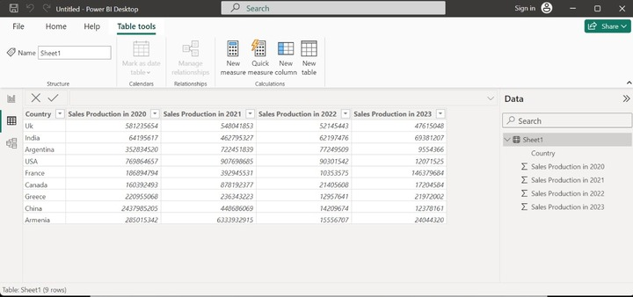
User is new in Power BI and unaware of how to build the visual for this table, he just intends to hide this table in the Report View. To do this, he clicked on the More options in the Data pane.
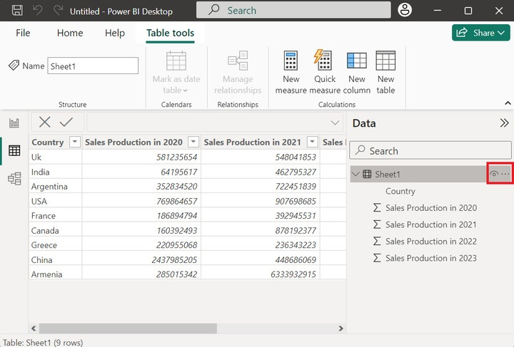
Once he selected the option "Hide in Report View" the table was not displayed in the Report View. The Data pane section shows the empty area.
